 **VELAMMAL BODHI CAMPUS**

**CLASS : X PART TEST-1**  **MARK:80**

**SUBJECT: ENGLISH Duration:3hrs**

#### Name of the Student : Date: 03.10.2023

**General Instructions:**

1. 15-minute prior reading time allotted for Q-paper reading.
2. The Question Paper contains THREE sections READING, GRAMMAR & WRITING and LITERATURE.
3. Attempt question based on specific instructions for each part.

**SECTION A- READING SKILLS 20**

#### I Read the passage given below. (10)

1.Why does humanity need Superman?”, wrote Lois Lane, the reporter from the Superman series. It’s a very relevant question in our context too. Why do we need superheroes? We are all enchanted by the action sequences in superhero movies, and also by how the superhero can always save the day – and with good reasons. If you’re trying to guess what it is, you can forget about powers like super-strength, laser vision, or — our personal favourite — the ability to consume any type of matter in the universe. The underlying reason we’re so enamoured of them is quite possibly the best superhero power – the way they can inspire and motivate us. From the smallest boy and girl wonders, to the oldest Captains – each superhero has had their own lesson to impart unto all of us.

2.Whether it’s Batman saving Gotham city, Superman saving humanity, or our very own Krissh saving his fellow countrymen – we need superheroes because they give us the hope and strength, we need to fight the injustice we encounter today. It’s like Batman once said, “Sometimes the truth isn’t good enough. Sometimes people deserve more. Sometimes people deserve to have their faith rewarded.” Yes, it’s true that we need faith today, when we know a lot tends to go wrong, whether it is with regard to terrorism, or growing crime – people need the hope and strength they get from superheroes. That’s why we need superheroes, because of how they give us a sense of right, which helps us fight the injustice happening around us. It was best summarised by Superman when he said that “There is a superhero in all of us, we just need the courage to put on the cape,” and by Batman in the Dark Knight, when he said that “You either die a hero or live long enough to see yourself become the villain.”

3. So, every time we choose to see a superhero movie, it gives us a nudge to fight the unjust with our own ideas o r capabilities. Every child and adult that watches superhero movies will be motivated to rise above the injustice happening in the real world. It’s not just about the power, but also the principle. You and I can also be a superhero just by helping our neighbours, and by standing against what is wrong. Whether the situation is political or apolitical, injustice can be fought with thoughts of righteousness and courage.

4. From the day we are born, we are told that power corrupts, and absolute power corrupts absolutely, but superheroes fan our subconscious desire for greatness. They also teach us that the greatest power is the integrity that keeps us from going down the wrong path. None of us will ever leap a tall building in a single bound, change the course of a mighty river, or bend steel with our bare hands but we can always return that lost wallet with its contents intact, tell the truth when it matters, stand our ground when it’s easier to walk away and unto others as we would want them to do unto us.

**Based on your understanding of the passage, answer the following questions.**

(i) Identify the sentence where the word “bestow” has been used incorrectly.

(a) He was ever-ready to take blame on himself and bestow praise on others.

(b) During the ceremony, the Prime Minister will bestow medals of honour to the brave soldiers who.

rescued their comrades.

(c) The king will bestow a title and land to the man who saved the princess.

(d) If you want to avoid a misunderstanding, I bestow you to consider your words before speaking.

(ii) According to the writer, how can a common man become a superhero?

1. Bend steel, change the course of rivers

2. Stand up against injustice, return that wallet intact

3. Help around the neighbourhood

(a) Only 1. (b) 2 and 3. (c) 1 and 3. (d) 1 and 2

(iii) Select the option that makes the correct use of “righteousness”, as used in para 3.

(a) Both sides in the dispute adopted a tone of moral righteousness.

(b) The newspaper reports are a righteousness of gossip.

(c) She was confused about obligation and righteousness.

(d) Cultural contexts bring righteousness in international relations.

(iv) What are the two things we need to fight injustice today? (2)

(v) What are the two meanings of “encounter” as used in para 2?

1. To experience something unpleasant

2. To experience something unexpected

3. To affect something

4. To cover with a thin layer

(a) 1 and 2. (b) 2 and 4. (c) 3 and 4. (d) 2 and 3

(vi) Despite our age and status in life, few enigmatic qualities endear us to superheroes. Select the correct options from below:

1. Give our subconscious a desire for greatness. 2. Have a lesson to bestow

3. Inspire and motivate us.

4. Give us hope to fight the bad

(a) 1 and 3. (b) 2 and 4. (c) 3 and 4. (d) 1, 2, 3 and 4

(vii) “There is a superhero in all of us, we just need the courage to put on the cape.”

By this, Superman is implying that ________. (2)

(viii) Write a suitable title for this passage.

#### II. Read the passage given below. (10)

#### 1.There are visible signs of economic rejuvenation since the second half of May, with the second wave of the pandemic abating in most parts of the country and state governments lifting restrictions in phases, a finance ministry report said on 10 August 2021 while calling for sustaining the vaccination progress and the need for Covid-appropriate behaviour. “The receding of India’s second wave, along with rapid progress in vaccination, has set the stage to further accelerate economic recovery. The movement of high frequency indicators in July clearly point towards a broad-based economic revival,” said the finance ministry’s monthly economic report for July, adding that these signs resonate with the fact that the economic impact of the second wave is expected to be muted.

#### 2. It said PMI manufacturing sharply rebounded to be in expansionary zone across output and input sub-components of the index. Marking swift economic recovery, GST collection has reclaimed its ‘ 1 lakh crore-plus territory in July, signifying increased business and consumer activity. Rail freight at 112.7 MT in July hit a record for the month and registered 18.3% growth (year-on-year) and 13.2% rise compared to pre-Covid July 2019.The surge in economic activity is further corroborated by trends in Kharif sowing, fertiliser sales, power consumption, vehicle registrations, highway toll collections, e-way bills and digital transactions, said the report. “Latest available data on growth of eight core industries, auto sales, tractor sales, port traffic, air passenger traffic, also indicate sequential improvement from the contraction induced by the second wave,” it further added.

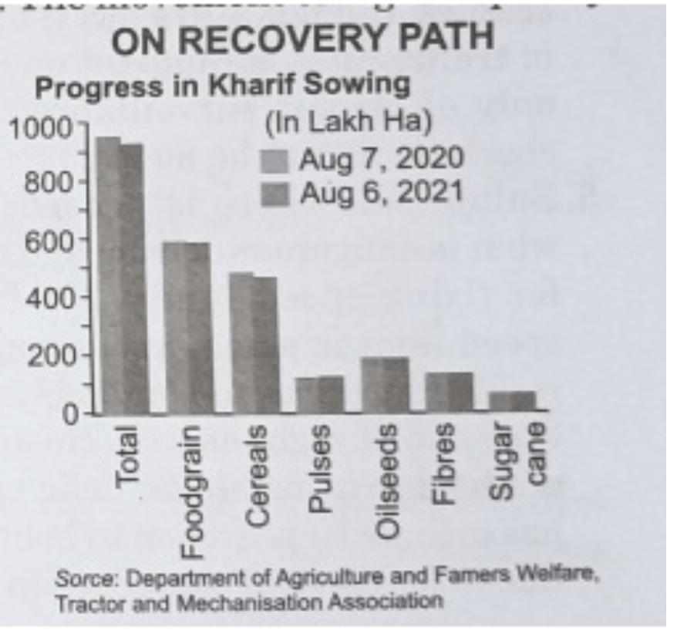

3. “At this juncture, the economy and society are at a crucial inflection point where sustenance of economic recovery, vaccination progress and Covid-19 appropriate behavioural strategies are needed in close synergy with each other.” It said that having antibodies reduces the probability of acquiring serious illnesses, as is borne by studies. So, any subsequent waves are expected to be mild in terms of severity of disease.

[Source: Times of India)]

### **Based on your understanding of the passage, answer the questions given below.**

(i) Why do you think the Indian economy is reviving now? (2)

(ii) In order to control and prevent Covid-19 cases, which is must? (2)

(iii)The term ‘Covid-appropriate behaviour’ refers to:(a) maintaining appropriate social distancing  
(b) wearing mask when going out of home  
(c) washing hands with soap and water and applying sanitizer frequently  
(d) all of the above.

(iv) What does the line “… the economic impact of the second wave is expected to be muted” mean?

(a) The impact of the second wave Covid-19 pandemic on economy would be very disastrous.

(b) The adverse impact of the second wave Covid-19 pandemic on economy would be to a very less extent.

(c) The impact of the second wave Covid-19 pandemic on economy would be to a large extent.

(d) The consequence of the second wave Covid-19 pandemic would be positive for economy.

(v) Based on the passage, what would be the impact of imminent wave Covid-19 pandemic in terms of severity of disease?

(a) very serious (b) enormous (c) mild (d) deadly

(vi) What does the GST collection of rupees 1 lakh crore plus territory in July 2021 reflect?

(a) Nominal business and consumer activity were done in July 2021.

(b) The condition of business and consumer activity was very bad in July 2021.

(c) Decreased business and consumer activity took place in July 2021.

(d) Increased business and consumer activity took place in July 2021.

(vii) Which one of these is an example of the term ‘year-on-year’?

(a) In March 2016, Aditi had received his electricity bill of 1540 and in May 2017, he received his electricity bill of रु450.

(b) In February 2020, I had earned 220,000, but in March 2020, I earned रु 15,000.

(c) In June 2020, Aryan had received his electricity bill of रु 1450 and in June 2021, he received the same supposed amount of his electricity bill.

(d) In May 2020, Sneha had spent 225,000 on household expenditure but in August 2020, she spent रु 30,000 on household expenditure.

(viii) Kiaan was vaccinated twice against Covid-19 virus. Which of the following statements is TRUE regarding Kiaan according to the passage?

(a) Covid-19 virus cannot affect him at all now.

(b) He may even acquire serious illness if he is infected by Covid-19 virus.

(c) If he is infected by Covid-19, he may become ill but his illness cannot be very serious.

(d) If he is infected by Covid-19, he may even die of it.

## 

## **SECTION B- GRAMMAR 10**

#### III Attempt ANY TEN of the following questions. 10

1. Fill in the blank by choosing the correct option to complete an online update.

The climate control comment -------- by an activist on social media yesterday.

* 1. Blow up
  2. Blew up
  3. Is blown
  4. Will be blown

2.Read the conversation between a doctor and his patient. Complete the sentence by Reporting the patient’s reply correctly.

Doctor: Do you feel down from time-to-time Mr. Gopalan?

Patient: Yes, I do not stay in a good mood.

The doctor, while trying to figure out his patient’s ailment, asked about his well-being, To which, the patient affirmed ------------

3. Select the correct option to fill in the blank for the given line, from a health Magazine.

The advertisement read, ‘If you smoke, statistically your story________________ end 15% before it should’.

A. must

B. should

C. will

D. Ought to

4. Complete the given narrative, by filling in the blank with the correct option:

As I was standing on the dock, looking out at the lake for the last time, a feeling of emptiness -------- over me like darkness.

A. will wash

B. had washed

C. Will have washed

D. Washed

5. Fill in the blank by choosing the correct option, to complete the slogan by the Ministry for Child Welfare.

----------- WE AFFORD TO NEGLECT CHILDREN? THINK TWICE!!

1. WILL
2. MAY
3. NEED
4. CAN

6 If you had let me know earlier, I ---------- have been able to come.

1. Would
2. Will
3. Shall

7 ----------- we leave now or do you want to wait?

1. Will
2. Might
3. Shall

8. I don’t speak Italian,” she said.

She said --------------

9. I ---------- the exhibition yet.

A. Am not seeing

B. Have not been seeing

C. Haven’t seen

D. Hadn’t seen

10. We -------- Mrs. Varma, when we were in Delhi

A. Have met

B. Will see

C. Met

D. Are Meeting

11. Aron, together with his wife ____ the guests of the party.

1. Greets
2. Greet
3. Greetings
4. Greeting

12. The truthful ____ always trustworthy

A. Is

B. Was

C. Are

D. May

**SECTION B- CREATIVE WRITING SKILLS 10**

#### IV 1.Attempt ANY ONE from A and B given below. (5)

A.You are Neena / Navin, a student of Max Public School, Mumbai. You are concerned about the lack of awareness around animal rights. Write a letter to the editor about the need to raise awareness about animal rights among the public.

#### Or

B.Write a letter to M/s. Oxford Publishing House, London complaining that the books sent by them were not those you had ordered for. Ask for a replacement. You are Varun Joshi, Sector-20, Chandigarh.

#### 2 Attempt ANY ONE from A and B given below. 5

A The following pie chart represents the distribution of the overseas tourists and their age profile respectively. Study the chart carefully and write an analytical paragraph giving the general trends and other necessary details. Don’ forget to compare the segments where relevant.

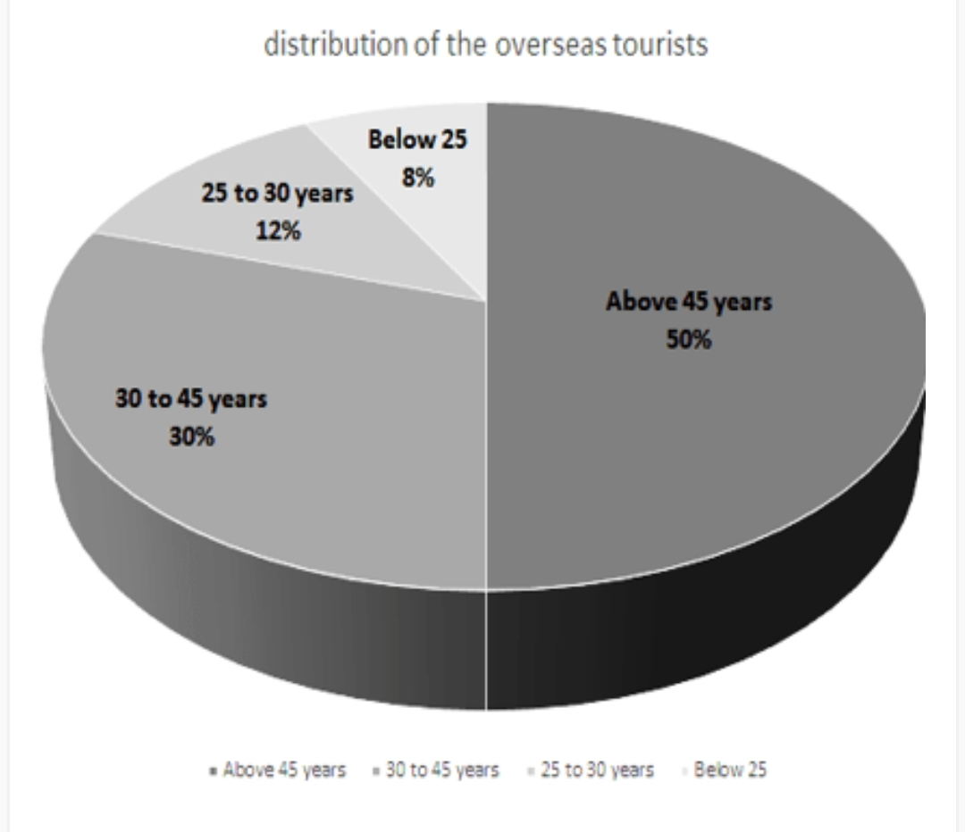

#### Or

B. The given pie chart represents the amount of money spent by a family on different items in a month. Write an analytical paragraph using the information given in the chart.

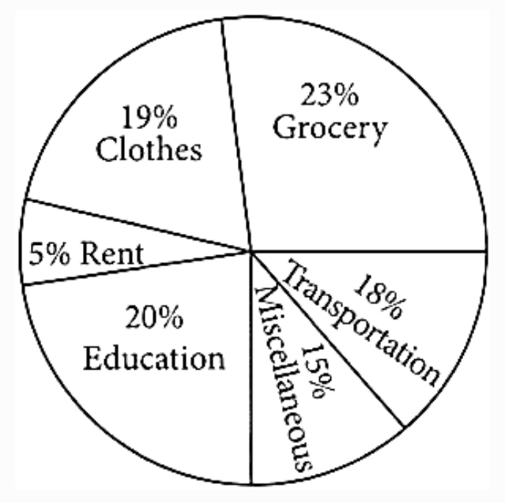

**SECTION C- LITERATURE**  **40**

#### V Reference to the Context 10

#### Attempt ANY ONE of two extracts given. (5)

#### 

#### A."Now we’re really going to get some

#### water, woman. The woman who was

#### preparing supper, replied, “Yes, God

#### willing”. The older boys were

#### working in the field, while the smaller ones were playing near the house until the woman called to them all, “Come for dinner. It was during the meal that, just as Lencho had predicted, big drops of rain began to fall. In the northeast, huge mountains of clouds could be seen approaching. The air was fresh and sweet. The man went out for no other reason than to have the pleasure of feeling the rain on his body, and when he returned he exclaimed, “These aren’t raindrops falling from the sky, they are new coins. The big drops are ten-cent pieces and the little ones are fives.”.

i. Why did Lencho say, “we are really going to get some water woman”? (2)

ii. At what time of the day ‘SUPPER’ is eaten?

a. Morning. b. Afternoon c. Evening. d. Night

iii. Which of the following sentences use the word ‘Until’ as used in the passage?

a. He started writing until 6’o clock.

b. Rupesh said that he would work until 4 pm.

c. I have been waiting here until 8’o clock.

d. You will begin work until the rain stops.

iv. Why was the air fresh and sweet?

a. due to a change in weather

b. due to corns growing in the field

c. Lencho’s wife made a dessert

d. due to flowers growing in his field

**OR**

1.B He just felt a bit dizzy. Then he flapped his wings once, and he soared upwards. “Ga, ga, ga, Ga, ga, ga, Gaw-col-ah,” his mother swooped past him, her wings making a loud noise. He answered her with another scream. Then his father flew over him, screaming. He saw his two brothers and his sister flying around him, curveting and banking and soaring and diving. Then he completely forgot that he had not always been able to fly and commended himself to dive and soar and curve, shrieking shrilly.

i) How would you describe the screams of the gulls in the given extract?

a) elation b) bewilderment. c) shock. d) protection

ii) Give the most appropriate reason why the young gull felt dizzy. (2)

iii) The line “he completely forgot that he had not always been able to fly” implies the

a) great confidence the young gull had in his skills.

b) naturalness of the act of flying for the young gull.

c) satisfaction and joy of flying together as a family.

d) desire of the young gull to leave his fears behind.

iv) The extract refers to the many movements of the young gull’s brothers and sister. Choose the option that correctly sequences these movements.

a) The young gull’s brothers and sister flew by, tilting their wings, rose high, made darting movements and plunged headfirst.

b) The young gull’s brothers and sister flew by plunging headfirst, making darting movements, titled their wings and rose high.

c) The young gull’s brothers and sister flew with darting movements, titled their wings, rose high and plunged headfirst.

d) The young gull’s brothers and sister flew by, rising high, plunging headfirst, making darting movements and tilting their wings.

2. **Attempt ANY ONE of two extracts given**. 5

A. I am an orphan, roaming the street.

I pattern soft dust with my hushed, bare feet.

The silence is golden, the freedom is sweet.

i) The tone of the given lines is

a) analytical. .b) despairing. .c) peaceful. d) nervous.

ii) Read statements A and B given below, and choose the option that correctly evaluates these statements.

Statement A – The figure ‘I’ imagines a less-than-realistic view of being an orphan.

Statement B – The figure ‘I’ does not like the speaker.

a) A is true, B is false, according to the extract

b) A is true, and B cannot be clearly inferred from the extract.

c) A cannot be clearly inferred from the extract, and B is false.

d) A is true and can be inferred from the poem, and B is true too.

iii) The golden silence is contrasted with the ______. (2)

iv) The rhyme scheme ‘aaa’ in the above extract is followed in all other stanzas of the poem that are written in parenthesis, i.e., (). Why?

Read the reasons given below, and choose the option that lists the most accurate reasoning:

(i) It shows the simplicity of the child’s thoughts.

(ii) It reflects the harmony and rhythm of the child’s inner world.

(iii) It mirrors a child’s expression.

(iv) It highlights the poet’s aesthetic sensibility.

a) (i) and (iv). b) (i) and (ii). c) (ii) and (iii). d) (iii) and (iv)

OR

2.B The way a crow Shook down on me The dust of snow. From a hemlock tree

i. What does the “dust of snow” symbolize in the poem?

A. A new beginning

B. A reminder of winter’s harshness

C. A transformative experience

D. We cannot determine from the stanza

ii. What is the significance of the crow in the poem? (2)

iii. What is the effect of the “dust of snow” falling on the speaker?

A. It makes him happy

B. It makes him sad

C. It makes him reflective

D. We cannot determine from the stanza

iv. What does the speaker mean by “the way a crow, Shook down on me”?

A. The crow landed on him

B. The crow caused the dust of snow to fall

C. The crow startled him

D. We cannot determine from the stanza

#### VI Answer ANY FOUR of the following in about 40-50 words each. 4 # 3 = 12

1. What does ‘fire’ and ice’ stand for and what is the general opinion regarding the world? (Fire and Ice)
2. Where did the ceremonies take place? Can you name any public buildings in India that are made of sandstone? (Nelson Mandela: long walk to freedom)
3. The tiger in the poem ‘A Tiger in the Zoo’ has some obvious limitations, describe them in contrast to its natural habitat.
4. Why was the young seagull afraid to fly in the lesson 'HIS FIRST FLIGHT'?
5. Why does Anne need to give a brief sketch about her family? Does she treat ‘Kitty’ as an insider or an outsider?(From the diary of Anne Frank )

#### VII Answer ANY TWO of the following in about 40-50 words each. 2 # 3 = 6

i. Why was Dr. Herriot confident that Tricki will be in hospital soon? (A Triumph of Surgery)

ii. What are the subtle ways in which the lady manages to deceive Horace Danby into thinking she is

the lady of the house? Why doesn’t Horace suspect that something is wrong? (A Question of Trust)

iii. Why was it difficult for Hari Singh to rob Anil? ( The Thief's story.)

#### VIII. Answer ANY ONE of the following in about 100-120 words. 6

i. “If you don’t help me, my family and I will go hungry this year.” Lencho had faith in God but he

didn’t manage to solve the problem by himself. Did he lack the courage to resolve his matter himself?

What values did he lack? Explain it. (A letter to God).

#### Or

ii. What does the poet say the boy is learning from the loss of the ball? Try to explain this in your

own words. (The Ball Poem).

#### IX Answer ANY ONE of the following in about 100-120 words. 6

#### 

#### i. With reference to `The Midnight Visitor’, do you think the presence of mind should be developed

#### and to what advantage? Elaborate highlighting the values possessed by Ausable.

#### Or

**2.**“Griffin was rather a lawless person.” Comment. (Footprints without Feet).